Clouds
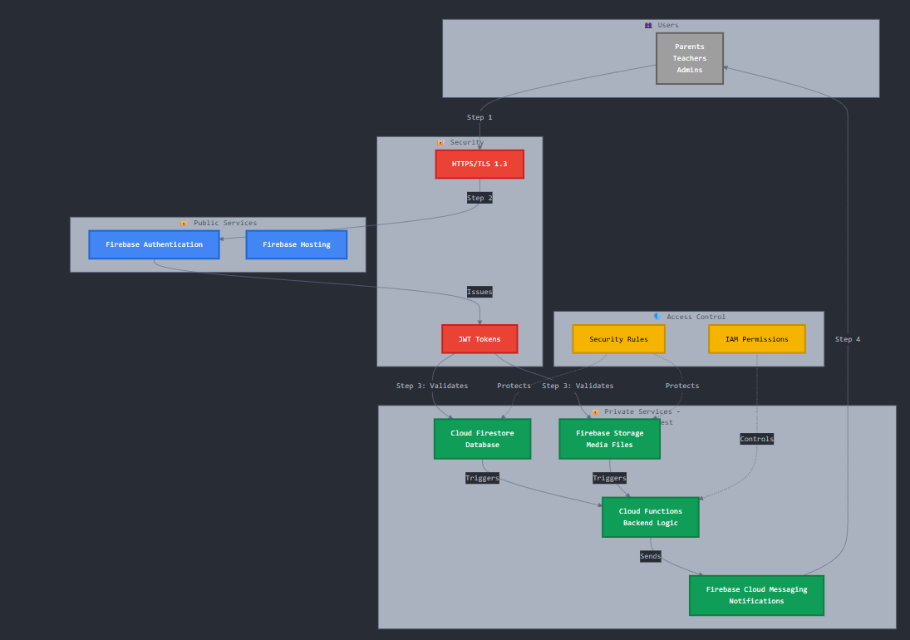 Figure 8: cloud architecture (Anthropic, 2025)
This diagram shows how your app's data is stored and protected in the cloud (Firebase).
The 4-Step Flow:
Step 1: User Connects
- Parents, Teachers, or Admins open the app
- Connection is encrypted with HTTPS/TLS (like a secure tunnel)
Step 2: User Logs In
- Firebase Authentication checks username and password
- This is a public service (anyone can try to log in)
Step 3: User Gets Access Token
- After successful login, Firebase gives a JWT Token (like a digital key)
- This token proves who you are and what you can access
- Token validates access to private services:
  - Cloud Firestore: Stores attendance, user profiles, notifications
  - Firebase Storage: Stores photos and documents
Step 4: App Works & Sends Notifications
- Cloud Functions process data (like marking attendance)
- Firebase Cloud Messaging sends notifications back to users. (Anthropic, 2025)
Security Layers:
Security (Red):
- All connections encrypted (HTTPS/TLS 1.3)
- JWT tokens expire after 1 hour (must login again)
Public Services (Blue):
- Anyone can access login page
- No sensitive data here
Private Services (Green):
- Contains all your important data
- Encrypted at rest (data is scrambled when stored)
- Only accessible with valid JWT token
Access Control (Yellow):
- Security Rules: "Parents can only see their own children's data"
- IAM Permissions: "Only authorized functions can send notifications". (Anthropic, 2025)
Real Example:
Teacher marks attendance:
- Opens app → HTTPS connection
- Logs in → Gets JWT token
- Marks student present → Token validates write to Firestore
- Cloud Function triggered → Sends notification to parent
- Parent receives push notification. (Anthropic, 2025)

Referencing
Anthropic. 2025. Claude Code (Version 1.0). [Large language model and code assistant]. Available at: https://www.anthropic.com/claude-code [Accessed: 13 October 2025].

